Software Requirements Specification
for
Scripture Alarm
Version 2.0

Prepared by
Group Name: Beta Development Team
Scott Stotlzfus | 2086093 | julianstoltzjager@gmail.com
Samuel Mills | 2110746 | sammills@letu.edu
T.C. Buscher | 2111181 | tcbuscher@letu.edu

Instructor: | Dr. Brent Baas
Course: | Software Engineering I
Date: | 18 February 2015
Contents
Contents ii
Revisions iii
1 Introduction 1
1.1 Document Purpose 1
1.2 Product Scope 1
1.3 Intended Audience and Document Overview 1
1.4 References and Acknowledgments 1
2 Overall Description 2
2.1 Product Perspective 2
2.2 Product Functionality 2
2.3 Users and Characteristics 2
2.4 Operating Environment 2
2.5 Design and Implementation Constraints 2
2.6 User Documentation 2
2.7 Assumptions and Dependencies 3
3 Specific Requirements 4
3.1 External Interface Requirements (SS, SM, TB) 4
3.2 Functional Requirements (SS, SM) 5
4 Other Non-functional Requirements 6
4.1 Performance Requirements (TB, SS) 6

Revisions
Version | Primary Author(s) | Description of Version | Date Completed
Initial Draft (V1.0) | Chelsea McFarland, Ieva Grinfelde, and Scott Stoltzfus | Initial draft of the Software Requirements Specification document | 02/04/15
Detailed Draft (V2.0) | Scott Stoltzfus, Sam Mills, and T.C. Buscher | Revision of the Software Requirements Specification document to add more detailed requirements | 02/18/15

Introduction
People nowadays do not get enough sleep, which means that they do not wake up in the mornings. This is especially true for Christian college students. These students have a vested interest in both waking up and memorizing scripture. The Scripture Alarm fills both these needs. It ensures that students wake up in time for class and memorize that bible verse for their Book of Acts test! This useful application can be downloaded directly onto a student’s iPhone.

Document Purpose
This document describes software whose purpose is to awaken people while also encouraging scripture memorization. This is the first release of the Scripture Alarm software. The software is intended for use on a mobile device, preferably the iOS platform. This document outlines the goals and specifications for the Scripture Alarm software.
IG, SS, CM

Product Scope
The primary purpose of this product is to incentivize customers to wake up in the mornings. The application will also aid in the memorization of scripture, or any other text. The length of the text will be limited to 250 characters.
IG, SS, CM

Intended Audience and Document Overview
This document is intended for the client, professor, and developers. The rest of this document continues to outline specifications and limitations for the Scripture Alarm application. It is intended to be read linearly.
IG, SS, CM

References and Acknowledgments
[1] K. Stuart. (2009, February 10). How to become an iPhone developer in 8 easy steps [Online].
Available: http://www.theguardian.com/technology/gamesblog/2009/feb/10/gamecultureapple

Overall Description

Product Perspective
This is a new product, which provides an unconventional way to get up in the morning. It was inspired by personal difficulties waking up. It forces the user to focus on a task in order to stimulate the brain.

Product Functionality
- Alarm
- Text storage
- Word dropping algorithm
- Entered text evaluation
- Progress tracker (optional)
IG, SS, CM

Users and Characteristics
Users of this product have difficulty waking up to their alarms. Additionally, they have a desire to memorize certain texts, thereby increasing their brain activity. This software can be useful to a wide variety of consumers, without limitations on age. Literacy is necessary for the use of this application.
IG, SS, CM

Operating Environment
This system will operate on iOS. It is intended for use on mobile devices, with the minimum system requirement being iOS 7. The Scripture Alarm will allow other applications to run until the alarm goes off. At that point, it will interrupt any application except a phone call. The phone will be the full integrated system.
IG, SS, CM

Design and Implementation Constraints
The size of the storage media on the cell phone is one constraint. A potential additional constraint is the authorization fee charged by Apple. The program will be limited to the Objective C programming language. Also, the coding will need to be done on a machine running at least the Leopard version of MacOS X. The software will need to be able to interface with Apple’s call application [1].
IG, SS, CM

User Documentation (TB, SS)
There will be little to no documentation for the product other than the Apple Store description. The product itself should be fairly straightforward to use.

Assumptions and Dependencies
- Programmers will be able to get a license from Apple.
- Programmers will be able to run MacOS X.
- That this software can run in the background, using minimal amounts of resources.
- That timekeeping is relatively simple to program.
- It will be easy to play basic sounds using the iPhone.
IG, SS, CM

Specific Requirements

External Interface Requirements (SS, SM, TB)

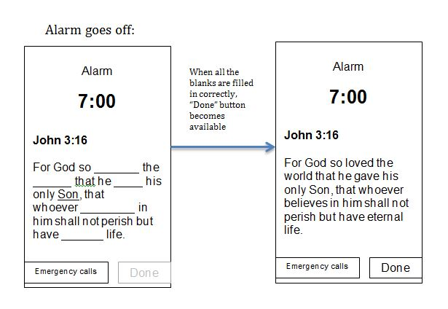
User Interfaces (SS)

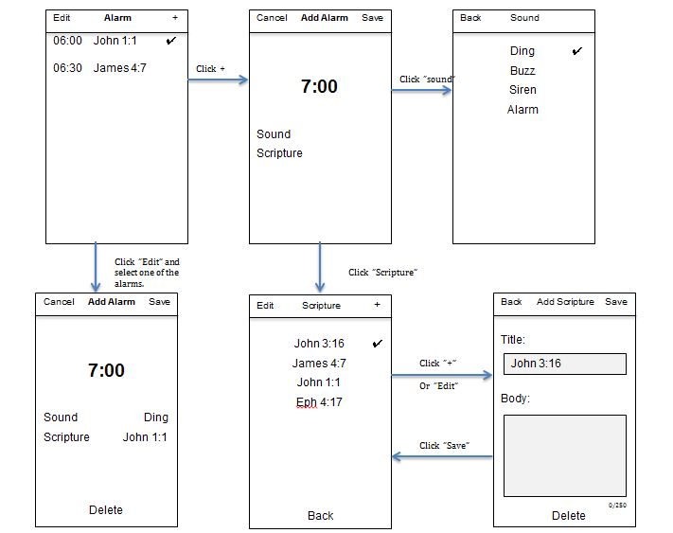

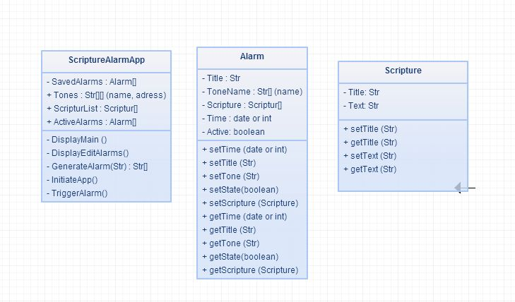
Software Interfaces (SM, SS)

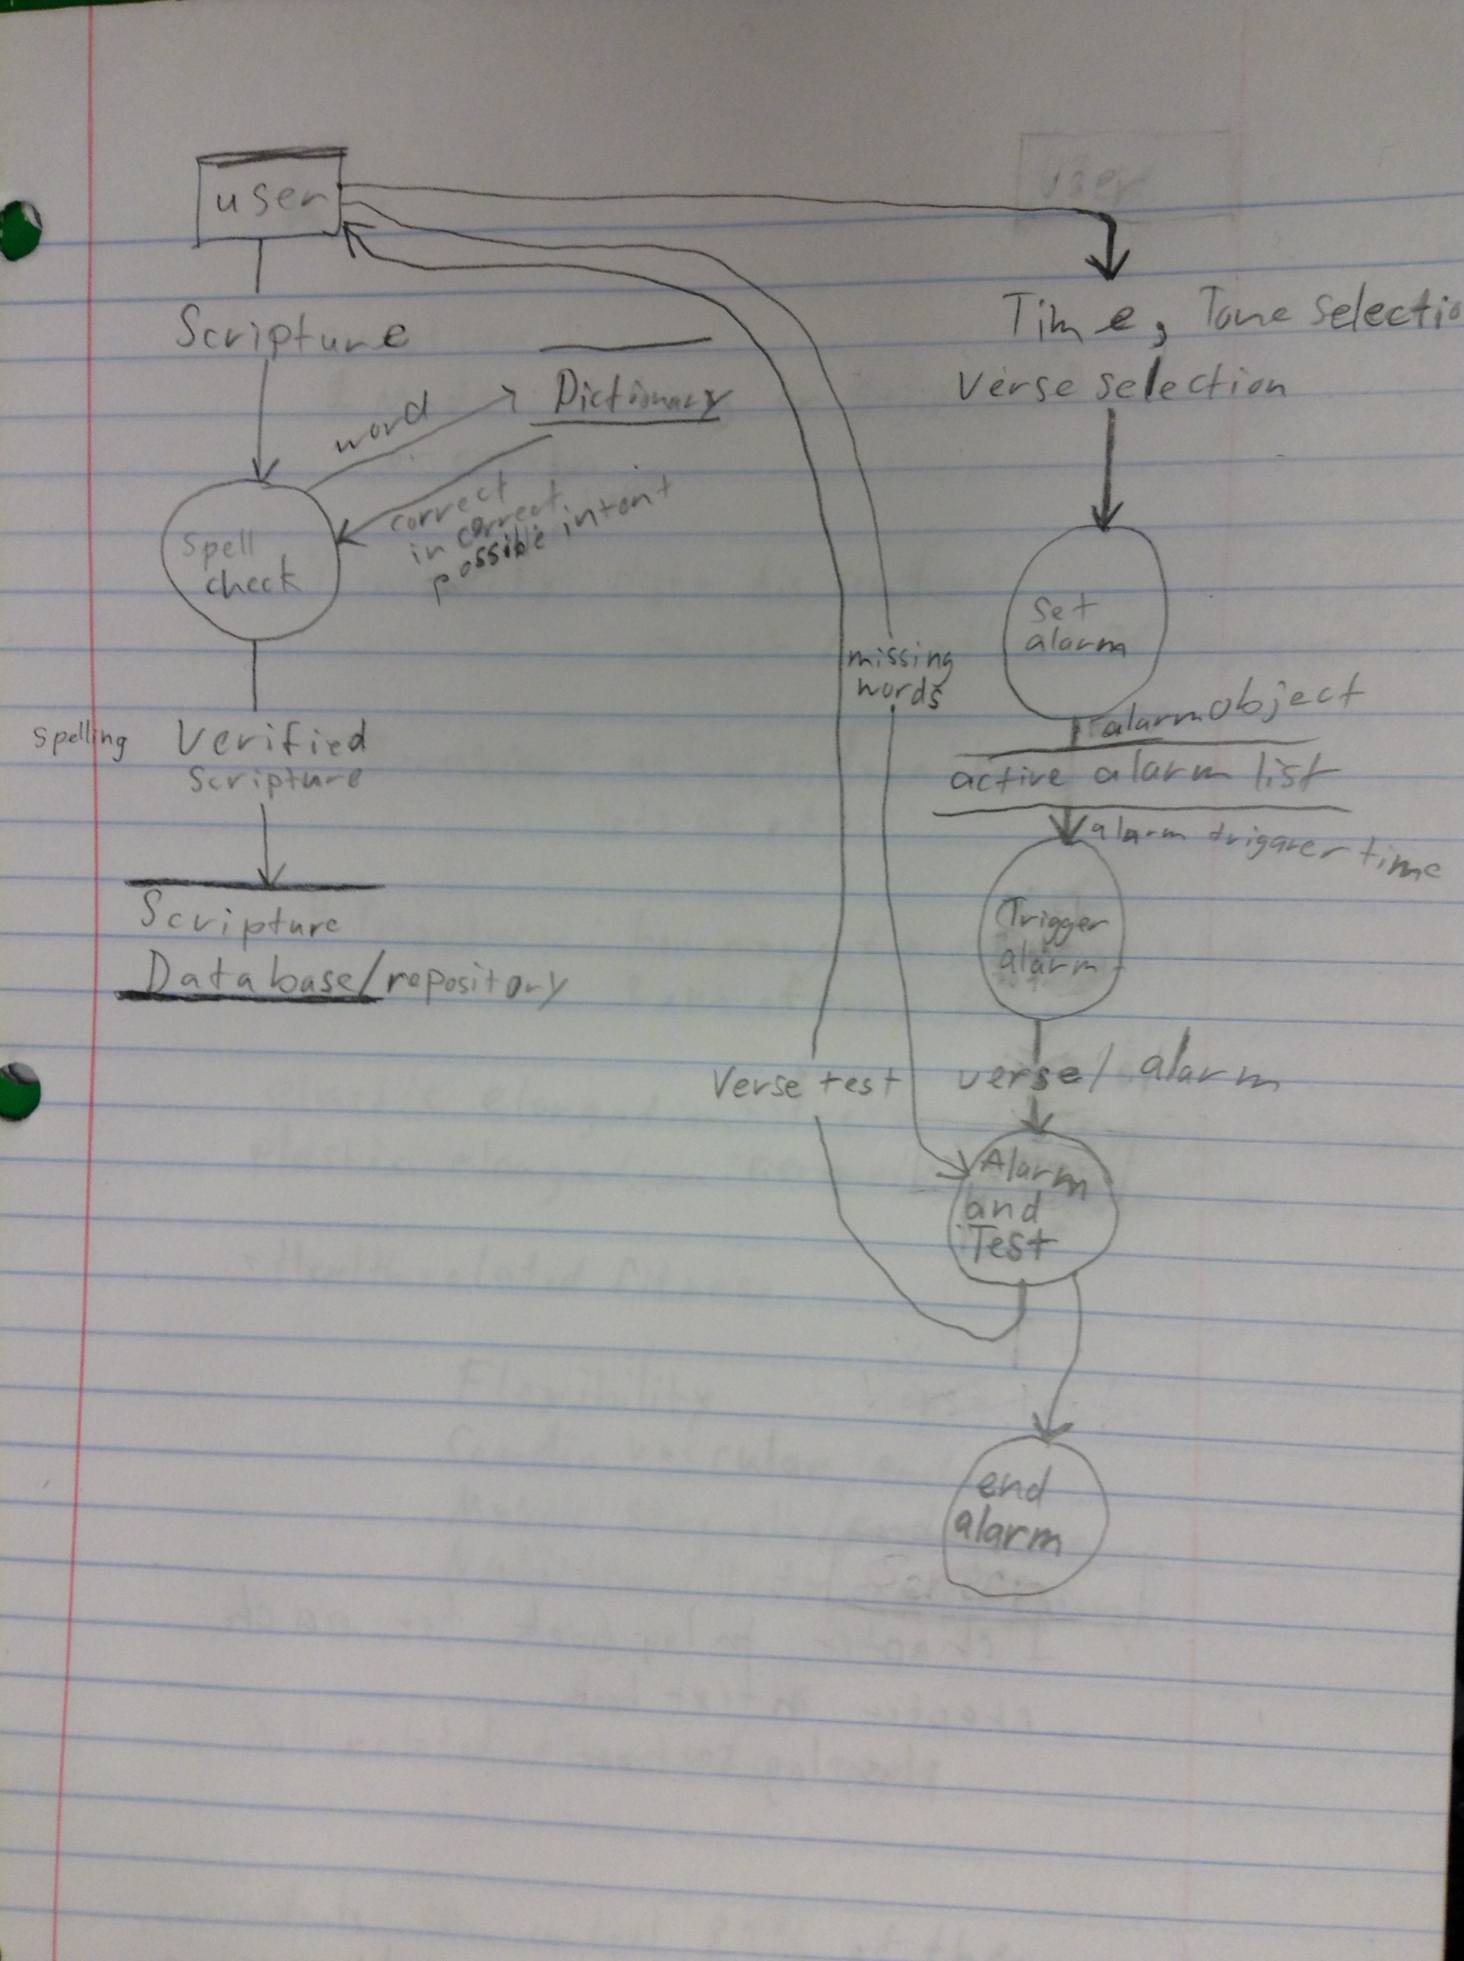
Functional Requirements (SS, SM)

Other Non-functional Requirements

Performance Requirements (TB, SS, SM)
- The verse length must be limited to 250 characters.
- The alarm must be reliable and play a simple alarm sound that the user can choose.
- The user must be able to input a personally chosen verse (or passage) to use for the alarm lock.
- The alarm must provide spell-checking capabilities while the user is inputting the words for the verse.
- The user must be able to choose the level of difficulty of the alarm lock.

